# Quick guide: colour polymorphism

Thomas E. White1, Darrell J. Kemp1

1Department of Biological Science, Macquarie University, Sydney, Australia 2109  
**Phone:** +61 2 9850 6279  
**E-mail:** thomas.white@mq.edu.au

***What is colour polymorphism?***

Colour polymorphism is the presence of multiple discretely coloured variants within a single population, the rarest of which is too common to be due to recurrent mutation. A requirement that the variation be genetic is included to distinguish polymorphism from polyphenism, which describes variation arising from interactions between a single genotype and varied environments. Sexual dimorphism, purely ontogenetic colour variation, and reversible colour change are also implicitly excluded. While polymorphism requires the coexistence of at least two morphs, the total number of variants within a population can vary considerably. Dramatic examples include the 'exuberantly' polymorphic Hawaiian happy-face spider *Theridion grallator*, with over 12 morphs coexisting across four Hawaiian islands, and the poison strawberry frog *Oophaga pumilio*, with over 20 true-breeding morphs across their Central American distribution (Figure 1).

***How do they develop?***

Colour in nature is typically a combined product of pigments that absorb light, and physical structures that reflect it. Both are highly sensitive to changes in their chemical and/or physical structure, and so relatively subtle alterations of the underlying protein-coding and regulatory genes can have dramatic phenotypic effects. Unsurprisingly, the genetic architecture and development of colour polymorphism is highly variable. In simple cases, morphs may be determined by allelic variation at a single locus that regulates colour production. The Midas cichlids *Amphilophus* sp., for example, exhibit a pigmentary dark-versus-gold polymorphism across both sexes that is controlled by a Mendelian locus with two alleles. In early life, both morphs are similarly dark thanks to broadly absorbent melanophores. In the ten percent of individuals that are homozygous for the recessive allele, however, these pigments degrade through ontogeny to expose the characteristic yellow-gold hue of underlying xanthopores.

Recent advances in sequencing have shown that polymorphisms may be controlled by clusters of loci that segregate as single supergenes. This physical linking of suites of genes allows for the maintenance of complex colour pattern variation while precluding less optimal intermediates, though much about how this is achieved remains unknown. Supergenes are particularly well documented among the strikingly ornamented *Heloconius* butterflies. In *H. numata*, each of seven morphs is determined by variation at a single locus. Unlike the Midas cichlids, though, this single locus is the switch for a supergene—constructed of numerous colour-coding loci—that controls chromosomal rearrangements corresponding to discrete wing colour patterns.

***Is it common?***

Colour polymorphisms are relatively rare, but are ecologically, taxonomically, and functionally widespread. They occur in species that inhabit the majority of terrestrial and aquatic habitats, and are found in most major groups of animals (Figure 1), as well as among flowering plants. Colour is often a valuable source of information about the world, and can also shape abiotic interactions, so polymorphism occurs in all almost all functional contexts that involve colour. This includes sexual signalling, mimicry, aposematism, mutualism, crypsis, thermoregulation and prey luring.

***Why are colour polymorphisms puzzling?***

Colour is a conspicuous feature of the natural world. It is a valuable channel of information, and so is often under strong selection across functional contexts. Colour polymorphisms have long been of interest in evolutionary biology because theory predicts that purifying selection should erode such variation in favour a single optimum. The persistence of extreme variation therefore offers a simple visual tool with which to explore the processes that generate and maintain variation. The has been exploited to great effect in ...

***So how is polymorphism maintained?***

Stable polymorphisms are thought to require some form of balancing selection to maintain equal fitness (on average) between morphs, lest a population be driven to monomorphism. There are several possible mechanisms, with varying degrees of empirical and theoretical support. Perhaps the best supported is negative frequency dependent selection, which occurs when rare forms enjoy a selective advantage. This translates into greater relative fitness that, in turn, increases the rarer morphs' frequency until it becomes the more common variant. The process is particularly common in the contexts of crypsis, in which predators more readily learn the common morph, and in sexual systems, in which colour morphs often correlate with discrete mating strategies. The side-blotched lizard *Uta stansburiana* is a classic example. Males occur in three forms—blue, orange, and yellow throated—that map onto distinct strategies for territory defence. Importantly, each enjoys a rare-morph advantage over only one other morph. Blue males are susceptible to invasion from orange, who lose territory to yellow individuals, who, to complete the rock-paper-scissors dynamic, cede territory to blue males. Their relative abundance predictably oscillates over short time scales, and the three-morph system appears to be evolutionarily stable.

Heterozygote advantage—where individuals that are heterozygotic at a given locus are fitter than their homozygous counterparts—is a well-established driver of allelic variation at large. Although historically thought to play a role in the maintenance of colour polymorphisms specifically, the possibility has found little direct support to date. Geographic and temporal variation in selection has also frequently been associated with colour polymorphisms, particularly in the context of communication. Theory suggests that such variation may create distinct niches that favour polymorphic solutions. This is particularly common in signalling systems where viewing environments, and hence the appearance of colour signals, may change over small scales. Again it remains unclear whether such variation is sufficient unto itself to maintain stable polymorphisms, and recent theoretical work suggests that it may need to act in concert with other processes such as sexual selection.

Ultimately, polymorphic populations will be subject to a suite of selective and neutral drivers. Disruptive selection, secondary contact, hybridisation, gene flow, non-random mating, and genetic drift, as well as those processes mentioned above, have all be implicated in colour polymorphic systems to some extent. Understanding the full complement of processes that maintain polymorphism, and quantifying their relative strength, is an ongoing challenge that has been achieved in very few systems.

***What are the consequences of colour polymorphism?***

Polymorphic populations often vary in more than just colour, because traits can become linked through correlational and epistatic selection, or shared developmental pathways. Between-morph differences in life history characters, behaviour, physiology, and morphology are all well documented. In such cases, discrete colour variation is just one visible component of broader genetic diversity, and theory suggests that this diversity may facilitate range expansions, colonization, and population persistence across spatially and temporally variable environments. These predictions are supported by indirect evidence from tangential fields, such as ecological and conservation genetics, but have been directly tested in few polymorphic systems. More broadly, it remains an open question as to how often colour polymorphisms arise via direct selection, as opposed to selection on suites of traits associated with or including the colour variation.

Perhaps the most extreme consequence of polymorphism is speciation, which may be realized through several paths. Sympatric. Although colour polymorphisms, by definition, occur within a single population, speciation need not be sympatric. Morph frequencies often vary geographically which can, for example, lead to reproductive isolation between populations at either end of their range. Some 20% of polymorphic birds show clinal variation in morph frequencies, and colour polymorphism has been empirically linked to accelerated rates of phenotypic evolution and speciation in these systems. Alternately, geographic variation in morph frequencies may be produced by secondary contact, which if there are costs associated with hybridization, such as when intermediate phenotypes are poorly adapted in an environment, selection is predicted to favour assortative mating within morphs in a process known as reinforcement. Such a polymorphism will necessarily be transient, and will ultimately produce monomorphic daughter species.

***Where can I find more?***

Bond, A. B. (2007) The evolution of color polymorphism: Crypticity, searching images, and apostatic selection. *Ann. Rev. Ecol. Evol Syst. 38*, 489–514.

Ford, E.B. (1945) Polymorphism. *Biol Rev* *20*, 73–88.

Gray, S.M., and McKinnon, J.S. (2007) Linking color polymorphism maintenance and speciation. *Trends Ecol. Evol. 22*, 71–79.

Mckinnon, J.S. and Pierotti, M.E. (2010) Colour polymorphism and correlated characters: Genetic mechanisms and evolution. *Mol. Ecol.* 19, 5101–5125.

McLean, C.A. and Stuart‐Fox, D. (2014) Geographic variation in animal colour polymorphisms and its role in speciation. *Biol. Rev.*

Roulin, A. (2004) The evolution, maintenance and adaptive function of genetic colour polymorphism in birds. *Biol. Rev.* 79, 815–848.

Wellenreuther, M. Svensson, E.I., and Hansson, B.(2014) Sexual selection and genetic colour polymorphisms in animals. *Mol. Ecol.* *23*, 5398-5414.

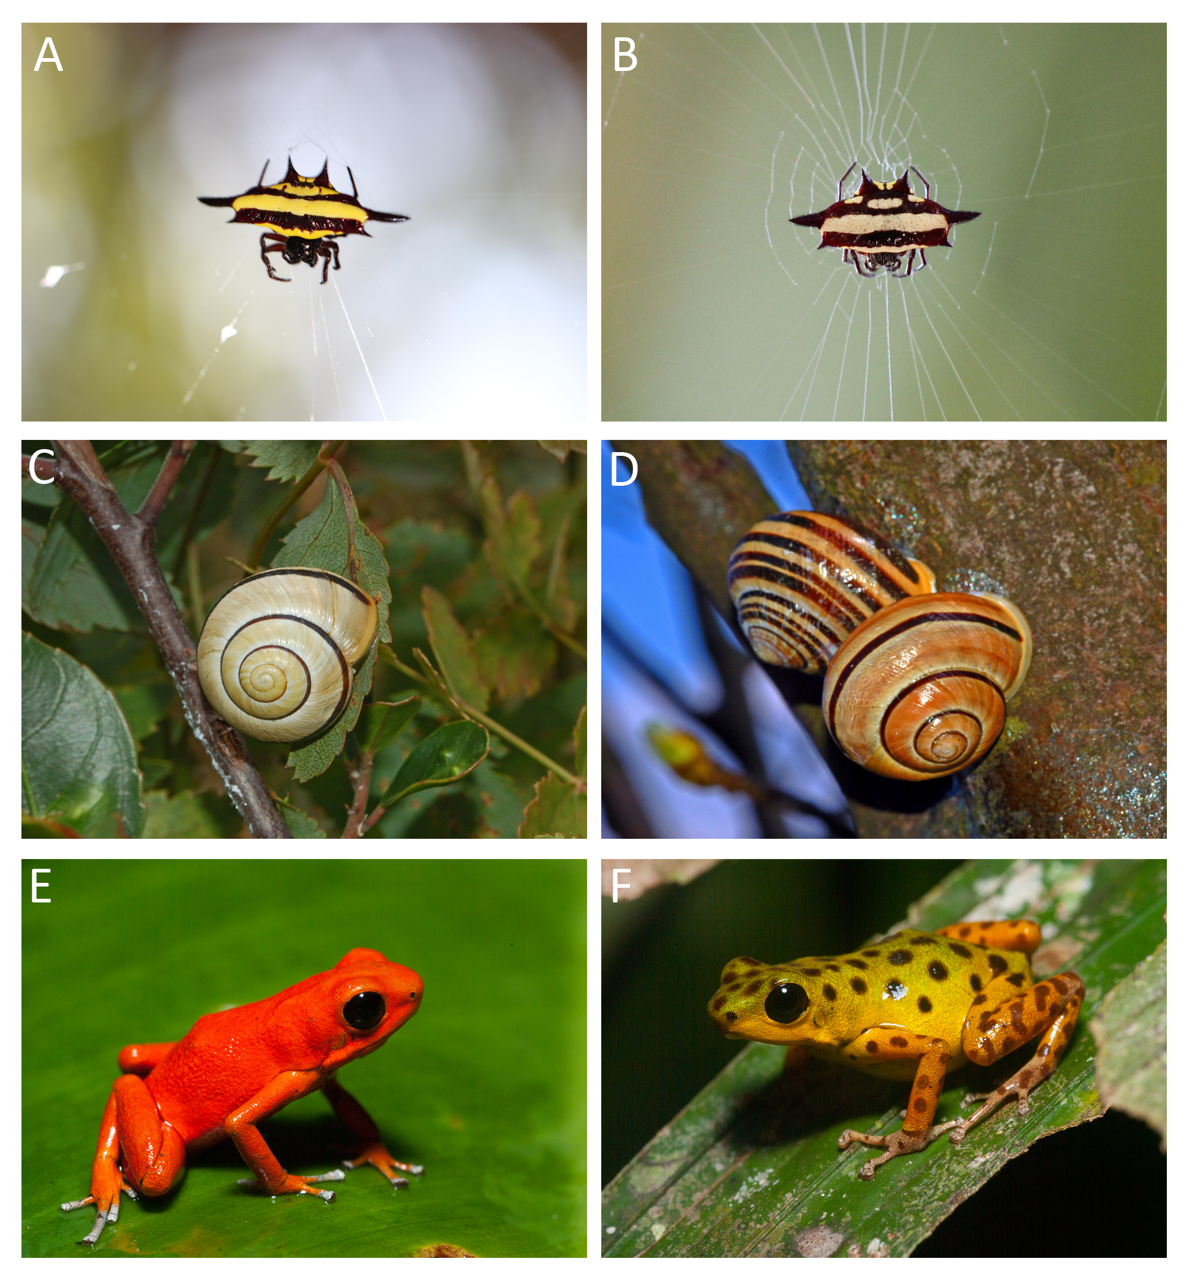Colour polymorphism in nature. (a, b) Both morphs of the spiny spider *Gasteracantha fornicata*, whose conspicuous colour patterns visually lure prey (Photos: Thomas White). (c, d) Colour and pattern variation in the highly polymorphic land snail *Cepaea nemoralis* (Photos: Ettore Balocchi). (e, f) Two of approximately 20 morphs of the aposematic poison frog *Dendrobates pumilio* (photos: Justin Lawrence).

# 